Student Handout for

Beginning Weaving 2 — Shoulder Bag

Winding the warp:
- For indirect warping you’ll need a warping board or 4-5 warping pegs. Gather some waste yarn, scissors, measuring tape, your worksheet and a pencil.
- For this project we a warp need about a 1.5-yard long and 6 inches wide. On your worksheet, note the number of ends (48) to wind and the length of the warp.
- For Color-and-Weave, knot together one strand of each color and wind them as a pair.
- A criss-cross should be created from every two passes at the point where the three pegs are close together. This is called “the cross”.
- Tie the counting string every 20 threads.
- A narrow warp like this only requires a single group or “bout” be wound.
- Once you’ve wound all passes, tie a bow around each arm of the cross. This is crucial!
- Tie a choke tie at both the start peg and the end peg.
- While the chain is still on the warping board, measure the length of your loom from front to back. Take this measurement back to the warping board and measure the same from the end peg (without the cross). Tie a choke tie at that measurement.
- Gently slip the end WITHOUT the cross from its peg. Insert your hand into the loop and arm-crochet the warp until you reach the cross. Insert a lease stick on one side of the cross, insert the other lease stick on the other side of the cross. Tape the ends of the sticks together, leaving a little space between the two sticks. Carry this to the loom.

Initial threading of the reed/heddle:
- Place the reed in the neutral position.
- Place the end of the chain with the lease sticks toward the reed/heddle and the rest of the chain hanging over the front beam.
- Tie the choke tie to the front beam. This is why you measured earlier. This will provide tension while you thread. You may turn the loom so you’re at the back of it.
- Mark the center of the reed/heddle with pencil or yarn. Measure 3” to the right (this is half the project width of 6”). Mark it with yarn.
- Remove the Texsolv cord from right-hand end of the rod. Try to maintain that little loop in the Texsolv. Make a pencil mark where the cord lived on the rod.
- Remove the ties at the cross, and also the ties nearby at the end of the chain.
- Counting at the cross, find the center of the warp (count in about 24 threads).
- Thread starting at the center of the reed/heddle, work towards the right, one loop per slot. Pass the yarn over the back beam and slide each onto the rod as you go. When finished with this half of the yarn, replace the Texsolv cord.
- Now remove the cord on the left side of the rod, mark with pencil where it was and resume threading at the middle of the project. When you reach the last thread, replace the Texsolv cord on the rod, and remove the lease sticks.
Rolling on:
- Straighten the warp on the back rod. Center the heddle.
- Undo the choke tie that’s been holding the bout to the front of the loom. Strum and snap the warp to straighten the threads.
- You or a friend can hold the warp and apply some tension. Alternately, you can set something heavy on the chain (a few books). You can also attach a weight to the bout and hang it off the end of the table.
- Turn the crank on the back beam. When the makes one full rotation around the beam, begin inserting warp sticks or heavy paper. Repeat, inserting 1-2 sticks per rotation. Paper should self-feed.
- When the end of the warp reaches the front beam, stop winding and cut the loop ends.

Final threading:
- For Color-and-Weave projects, the colors of thread generally alternate. Follow the instructions below to see which color is threaded into slots (down) and which color is threaded into holes (up). Pay close attention because they periodically swap.
- When finished, double check your threading, then center the heddle/reed.

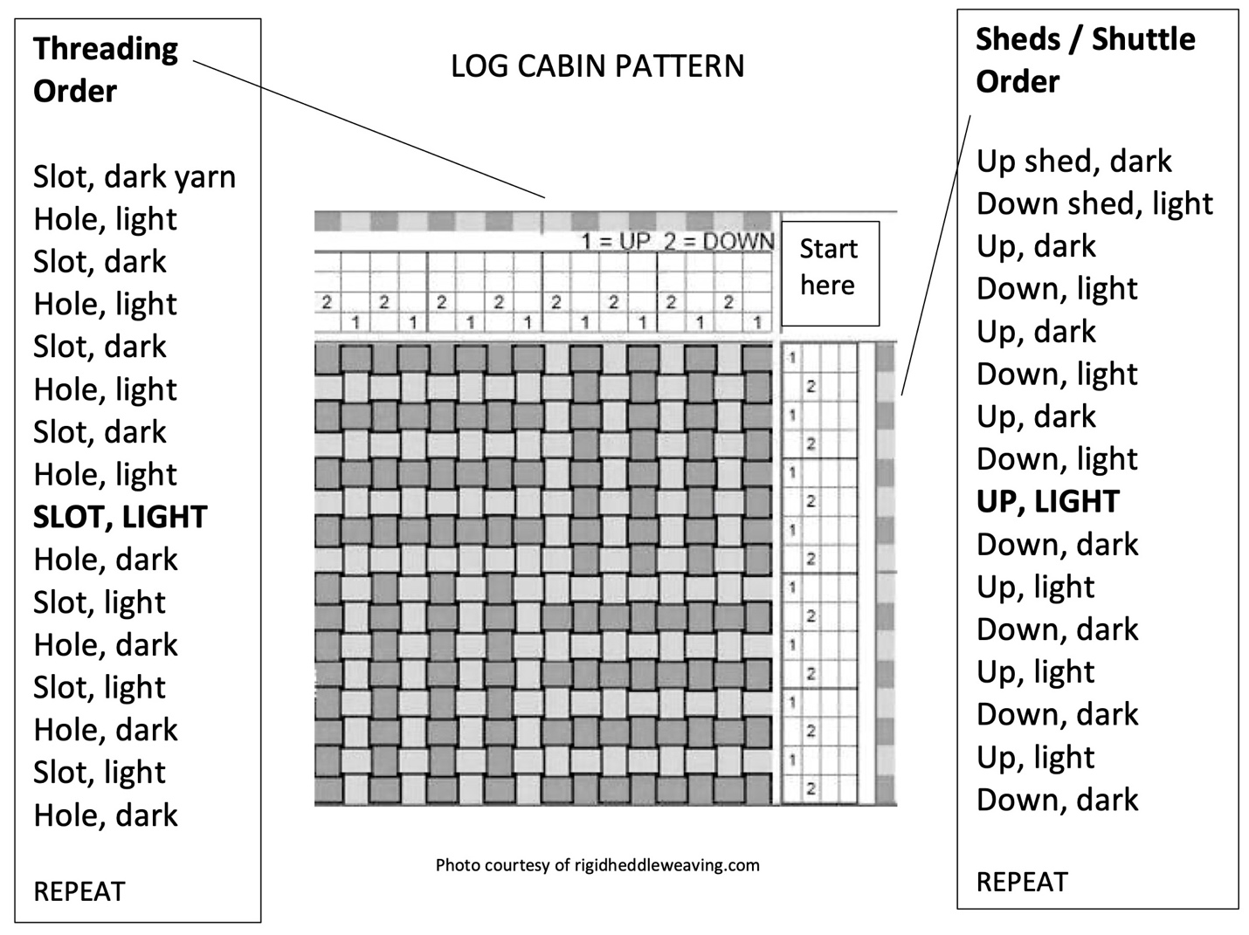

Tying on:
- Bring the front rod up and over the front beam. Center it.
- Starting just right of center, grasp about an inch of threads and divide in half.
- Pull the halves (one in each hand) over, then under the rod and then tie the ends over the 1” section like tying your shoes but with one extra throw.
- Repeat with the 1” group just to the left of center. Tighten the gear one click.
- Work across the warp, alternating groups to the left and right.
- Remove most of the slack with the ratchet gears.
- Next, slide the ends of the first group toward the reed/heddle, removing any additional slack. Use your thumbs. Pull the ends sideways and back toward yourself. The 1” group of yarn should feel firm but not super tight. Repeat across the warp.
- Once the groups have even tension, tie each in a knot.
- Position the front rod near the front beam.

Starting to weave:
- Open the Up shed and insert a length of waste yarn, but don’t beat.
- Open the down shed, insert a length of yarn close to the previous yarn, but don’t beat.
- Open the Up shed again, insert a third length of yarn. Now beat / pull all three picks at once until they’re about 2” from the tie-on rod. This spreads the warp threads evenly and moves looseness from the weaving area. This is the only time you’ll beat 3 together.
- Weave 1-2” headers to check that the fabric is working (no threading mistakes). Also check the strength of your beat and correct picks per inch (PPI). You can use waste yarn for this but it should be the same weight as your weft yarn.
- When you start the actual project / fabric, leave a 3” tail off the side. On your second pick, tuck that tail into the new shed.
- Follow the shed/shuttle order in the diagram above.
- Advance the warp often. Put the heddle/reed in neutral, crank the back gear away from you, lift the ratchet, then wind the fabric toward yourself.
- Winding the shuttle: Wind a few passes of weft yarn around the shuttle passing from one notch to the other. Then turn the shuttle so the thin edge is up and wind the weft yarn in a figure eight. It will protrude off the “side” of the shuttle. Turn the shuttle to the other thin edge and repeat. This method prevents the shuttle from getting hung up in the shed.
- As you pass the shuttle, do not allow it to pull in the outside-most thread, called the selvedges. Pinch the fabric to hold the edge steady as you gently pull the shuttle through the shed. On wider projects in the future we’ll have other options.
- Lay the weft yarn at a 45-degree angle. This is so important!
- Advance the warp regularly so you are weaving in the loom’s “sweet spot”.

Finishing
- Sew a straight line across the first pick of weaving and across the last pick of weaving. Be sure to catch all the warp yarns of the weaving!
- Sew a straight line seam up each side of the bag, leave ½ allowance.
- Braid (or spinners can ply on their spinning wheel) 6 strands of worsted weight yarn. Do this in 2 groups of 3 strands. You can also purchase ribbon, cord, or a strip of suede.
- Insert the strap into the seam allowance and sew it in.
- Hand wash gently in cool water.
- You can finish further with a magnetic clasp, Velcro, or snap.

